Experiment 6: write a Python program to implement the Vacuum Cleaner Problem

Aim
To write a Python program to implement the Vacuum Cleaner Problem using a simple reflex agent.

Algorithm
- Initialize the environment with two rooms (A and B).
- Check the current room.
- If the room is dirty, clean it.
- If the room is clean, move to the other room.
- Repeat until both rooms are clean.
- Display the actions performed and the final state.

Program
rooms = {
'A': 'Dirty',
'B': 'Dirty'
}

current_room = 'A'

while True:

print("Current Room:", current_room)
print("Room Status:", rooms[current_room])

if rooms[current_room] == 'Dirty':
print("Action: Clean")
rooms[current_room] = 'Clean'
else:
print("Action: Move")

if current_room == 'A':
current_room = 'B'
else:
current_room = 'A'

if rooms['A'] == 'Clean' and rooms['B'] == 'Clean':
break

print("\nFinal Room Status:")
print(rooms)

Output
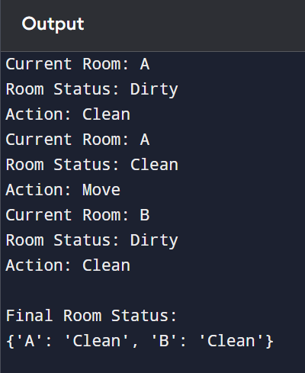

Result
Thus, the Python program to implement the Vacuum Cleaner Problem using a Simple Reflex Agent was implemented successfully, and both rooms were cleaned.

